- Tên và phân loại:

- Mục đích, ý nghĩa:
Define a one-to-many dependency between objects so that
when one object changes state, all its dependents are notified
and updated automatically
- Động lực sử dụng:
- In a spreadsheet application, several views of the same essential
data are to be displayed on the screen simultaneously
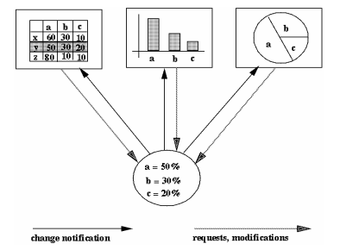
- Khi nào sử dụng:
- When an abstraction has two aspects, one dependent on the
other. Encapsulating these aspects in separate objects lets
you vary and reuse them independently
- When a change to one object requires changing others, and
you don't know how many objects need to be changed
- When an object should be able to notify other objects without
making assumptions about who these objects are. In other
words, you don't want these objects tightly coupled
- Cấu trúc
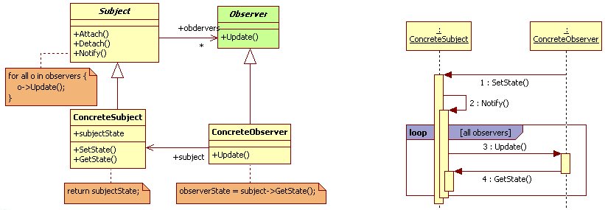
- Các thành viên - Sự cộng tác
- Subject
• Knows its observers. Any number of Observer objects may observe a subject
• Provides an interface for attaching and detaching Observer objects
- Observer: defines an updating interface for objects that should be
notified of changes in a subject
- ConcreteSubject: stores state of interest to ConcreteObserver objects
- ConcreteObserver
• Maintains a reference to a ConcreteSubject object
• Stores state that should stay consistent with the subject's
• Implements the Observer updating interface to keep its state
consistent with the subject's
- Các hệ quả mang lại:
- Abstract coupling between Subject and Observer
• All a subject knows is that it has a list of observers, each conforming to the
simple interface of the abstract Observer class. The subject doesn't know
the concrete class of any observer. Thus the coupling between subjects
and observers is abstract and minimal
• Because Subject and Observer aren't tightly coupled, they can belong to
different layers of abstraction in a system. A lower-level subject can
communicate and inform a higher-level observer, thereby keeping the
system's layering intact
• If Subject and Observer are lumped together, then the resulting object
must either span two layers (and violate the layering), or it must be forced
to live in one layer or the other (which might compromise the layering
abstraction)
- Support for broadcast communication
• Unlike an ordinary request, the notification that a subject sends needn't
specify its receiver. The notification is broadcast automatically to all
interested objects that subscribed to it
• The subject doesn't care how many interested objects exist; its only
responsibility is to notify its observers. This gives you the freedom to add
and remove observers at any time. It's up to the observer to handle or
ignore a notification
- Chú ý liên quan đến cài đặt:

- Hệ thống thực tế

- Mẫu liên quan
- Mediator: By encapsulating complex update semantics, the
ChangeManager acts as mediator between subjects and observers
- Singleton: The ChangeManager may use the Singleton pattern to
make it unique and globally accessible

